The technology of processing information and recognizing gas mixtures using a multisensory system based on the use of neural networks

IvanovA.I.,
Penza Research Electrotechnical Institute
Penza, Russia
ivan@pniei.penza.ru
KulaginV.P.
Moscow Technological University MIREA
Moscow, Russia
vkulagin@mirea.ru
Member, IEEE

Kaperko A.F.¹, KuznetsovY.M.², Obolyaeva N.M.³, Chulkova G.M.⁴, Yurin A.I.⁵
School of electronic engineering, National Research University "Higher School of Economics"
Moscow, Russia
¹akaperko@hse.ru, ²ykuznetsov@yse.ru, ³nobolyaeva@hse.ru, ⁴gchulkova@hse.ru, ⁵ayurin@hse.ru
ShustrovA.V.
Manufacturing and Technology Center "UralAlmazInvest" Ltd.; Moscow, Russia
av.shustrov@gmail.com

Abstract—We consider the technology of information processing and the use of neural networks to identify complex gas-air mixtures with a multi-sensor system of the "electronic nose" type equipped with semiconductor gas sensitive sensors. We also present the results of our experimental studies of the recognition of various gas mixtures based on the application of neural networks in the process of processing signals from a multisensor system of gas-sensitive sensors.
Keywords— multisensory system, information processing technology, electronic nose, neural network

INTRODUCTION
The creation of small-size devices based on gas mixture sensors is widely used in modern analytical practice. Modern technologies of electronic instrumentation provide a qualitatively new level of analytical instrumentation. This is due to the use of a matrix of parallel-acting gas mixture sensors in combination with modern digital processing of multiparameter signals. When using a multi-sensor system of the "electronic nose" type equipped with semiconductor gas sensitive sensors, it becomes possible to extract with known accuracy information about both the composition and the concentration of individual components in multicomponent gas mixtures.
Unlike traditional gas analyzers (gas chromatographs, chromatography-mass spectrometers, etc.), the multi-sensor system of the "electronic nose" type can use low-selectivity sensors and, due to the use of computer technology and modern methods of information processing, to achieve recognition of complex gas-air mixtures.
The multi-sensor system of the "electronic nose" type can be based on gas sensors made on the basis of metal oxide semiconductors (MOS) [1], polymer composite materials [2], and quartz microcavities (QCM) [3].
Gas sensors based on metal-oxide semiconductors, nanoscale oxide materials, which have become most widely used recently in the development of multi-sensor systems of the "electronic nose" type due to their high sensitivity and relatively low cost, are used as a sensitive element [4]. The principle of operation of such gas-sensitive sensors is based on the change in the electrical conductivity of the sensing element of the sensors when interacting with molecules of gas substances. Usually the sensor does not have a high selectivity to any one substance, however, the mathematical processing of the signal from a multi-sensor system containing 4 to 30 gas sensitive sensors makes it possible to obtain a unique "image" of the smell of the gas mixture.
Typically, the signal processing system in a multisensory "electronic nose" type manifold and odor recognition using statistical processing of the data [5] "decision trees" [6], fuzzy logic [7], principal components analysis (PCA) [8,9]. For the processing of information and pattern recognition in the multi-sensor system of the "electronic nose" type, capable of recognizing a wide class of gas mixtures, the most promising and often used methods are trained neural networks [10-12]. Neural networks are a computer simulation of interacting human neurons of the human brain and are an example of nonparametric methods of pattern recognition. The process of pattern recognition in a multisensory system, as a rule, is carried out in three stages: extraction from the array of data of characteristic features, classification and identification.
The use of trained neural networks with certain neuron properties, weight factors and network topology determine the basic capabilities of the network - filling it with "knowledge." The purpose of training a neural network is to minimize the errors of output signals, for example, the concentration of components of the mixture being analyzed. Training consists in solving the optimization task of determining the values of all external factors (temperature, humidity) and factors of partial sensitivities when working with a set of data in samples of known composition. Such a set of data should be sufficiently representative and cover the entire range of concentrations of all the gas components being determined. The number of samples required for complete network training depends on the complexity of the problem being solved.
In this article the technology of information processing and recognition of the gas mixture at example multi-sensor system type "electronic nose" (highly intelligent artificial nose) through the use of gas-sensitive solid matrices..

DESCRIPTION LAYOUT DEVICES FOR RECOGNITION OF THE GAS MIXTURE
To recognize the composition of gas mixtures and evaluate the effectiveness of the application of the neural network method for identifying complex gas-air mixtures, a model (an experimental sample) of a multi-sensor system of the "electronic nose" type was developed, the block diagram of which is shown in Figure 1. The gas-sensitive sensor array (1) is implemented on the basis of solid-state semiconductor metal oxide sensors designed to analyze the composition of the gas mixture. It consists of 10 gas-sensitive sensors that differ in sensitivity and selectivity to the effects of various chemicals, namely: Air Composition Sensor TGS2600, Air Composition Sensor TGS2602, Combustion Sensor TGS2610-C00, Sensor for Methane TGS2611-C00, Sensor for Methane TGS2611-E00, Sensor for methane-propane-butane TGS2612, Sensor for alcohol TGS822, Sensor for ammonia TGS826, Sensor for CO TGS3870-B04, Sensor for freon TGS3830, Humidity sensor HIH6103-021-001.

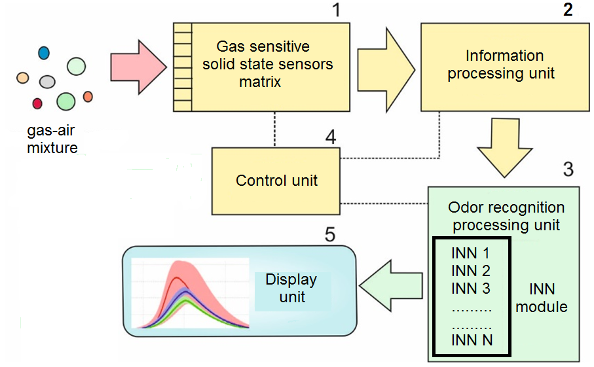
Figure 1. A block diagram of the layout of a neural-network multisensor system for recognition of gas mixtures

The work of gas-sensitive sensors is based on the change in the electrical conductivity of the semiconductor film of each sensor due to the adsorption of gas on its surface with the external action of the test substance. For the matrix, sensors were chosen that had a metal oxide semiconductor layer 1 μm thick as a material for the sensitive element, providing high sensitivity to a specific type of gas, namely, air (air polluting gases, CO2), explosive gases (methane) as well as sensitivity to the analytes , propane, hydrogen), propane-butane, alcohol, ammonia, CO, freon. In experimental studies, it was taken into account that each sensor of the matrix simultaneously exhibits sensitivity to various types of substances in the gas mixture and, at the same time, provides an optimal selectivity to a certain type of chemical gases, which is also determined by the specific heating temperature of the sensor sensor, which in the measurement mode was 60-260 °С.
For signal processing gazochuvstvitelnye multisensor matrix used information processing unit (2) which provides digitization of the output signals generated in the array of gas-sensitive sensors, i.e. formed a digital "image" of the substance under study.
Detection of gas-air mixtures carried in the embedded recognition unit odors (3) specify the algorithm implemented in an original computer program "Chemical Classification ENoseMath» (state registration certificate № 2017610942 of 19.01.2017).
The control unit (4) performs control of the operating modes of all device units: heating of the sensors according to a certain program, switching on and off of pumps supplying the analyzed air, removal of foreign gases and vapors. The display unit (5) is intended for displaying on the screen information about the operating modes of the device: obtaining initial data on the image of the smell; search by database of images of smells; analysis of the concentration of mixtures of detected smells; transition to a learning mode of a new image of a smell; evaluation of the probability of errors in the detection of a new odor. In addition, graphs and histograms, which are the results of statistical data processing, can be displayed on the screen of the display unit.
The method of certification and application of the gas mixture preparation device is based on the requirements of GOST R ISO 6144-2008 "Preparation of calibration gas mixtures. Static volumetric method ", which includes:
- The order of preparation of the calibration gas mixture for obtaining gas and vapor-gas mixtures used for carrying out experimental studies.
- calculation of the volume fraction of the target component in the gas mixture.
- calculation of the uncertainty of the content of the target component in the gas mixture.
The cycles of research trials were carried out automatically without the participation of the operator. Recording of the received data in the "Learning" and "Detection" modes (date and time of measurements, temperature, humidity, the investigated environment, cycle number, digital recording of "smell image" for all gas sensitive sensors, service attributes) was realized using the "SensProgMain_2016" . Data processing from the sensor gas sensor array is carried out by software components "Electronic nose software" ENoseMath through the appropriate programming interface.

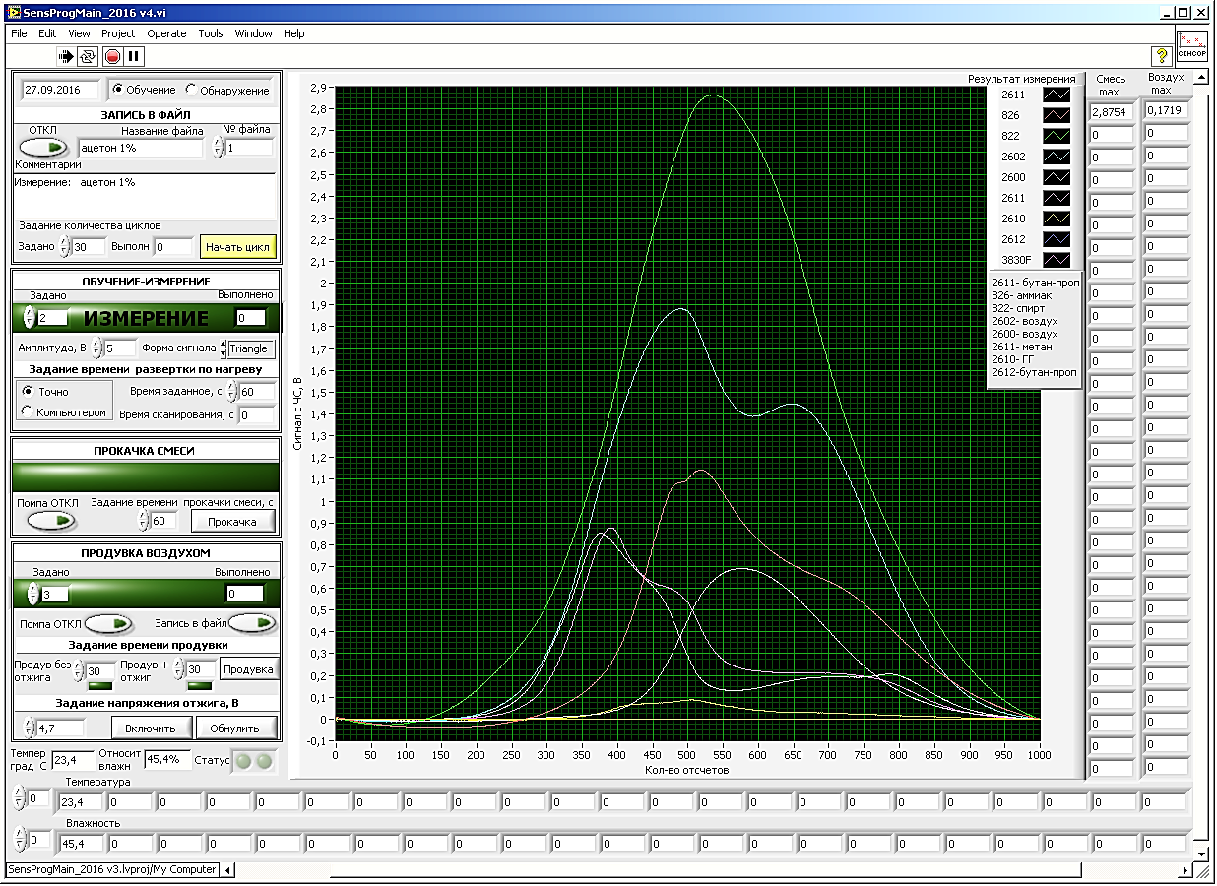

Figure 2. User interface of the executive program "SensProgMain_2016"

In addition, for a complete cycle of studies it has been designed and manufactured a set of components and assembly tooling in the form of hardware and technical complex consisting of:
- a cryogenic cleaning unit that provides purification of the air and gas environment and removal of residual gases, hydrocarbon components and residual water vapor,
- the block of the electronic-mechanical control of the cryogenic cleaning unit, which provides the supply of liquefied helium to the cryogenic cleaning unit,
- two-channel gas inlet unit, which provides the formation of a reference artificial air mixture (80% of nitrogen gas, 20% of gaseous oxygen),
- mounting docking flanges, providing the junction of the kit with the gas mixing chamber,
- Vacuum gas supply, providing a vacuum-tight connection of the gas inlet assembly to the gas-mixing chamber.

III. METHODS OF EXPERIMENTAL RESEARCH
The tests included the following main technological stages (cycles):
1. Training of the experimental sample to the target substance, including in the presence of background substances (the so-called "Aliens"), the formation of a database of images of gas components.
2. Preparation of the air-gas mixture of the target substance or mixture of the target and interfering substances of a given concentration is carried out in a gas-mixing chamber by specially developed methods.
3. Preparation of gas-sensitive sensors for a multisensory system for carrying out experimental studies. Preparation of sensors and a gas mixing chamber is carried out at all stages of experimental research and is carried out immediately before the start of a series of experiments. The interval of time at the end of preparation and the beginning of a series of experiments should not exceed 5 minutes.
4. Detection of the target substance ("Friend") by the experimental sample, including in the presence of background substances.
Since the course of adsorption depends on the gas concentration, the experiments were conducted in a wide range of concentrations: 50-1000ppm. The concentration range of the target substances was chosen taking into account the need to determine the threshold concentrations of the investigated substances by a device such as an "electronic nose", while in the range of small concentrations the concentration step was 10 ppm, after 100 ppm, the step = 20 ppm, after 200 ppm, step = 100 ppm , after 1000 ppm - step = 1000 ppm. The concentration values were calculated by the volume of the target substance introduced into the gas mixing chamber. Table 1 presents the investigated organic chemicals involved in experimental studies.
The calculation of the number of gas molecules in a gas-mixing chamber was done on the basis of the Mendeleev-Clapeyron equation:

$$P∙V_{0}=\frac{m}{M}∙RT (1)$$

where: P - gas pressure, 1 atm = 760 mm Hg = 1.03 10⁵ Pa;
V₀ - volume of gas of one mole of substance;
m is the mass of the gas, g;
M is the molar mass, g
R - universal gas constant - 8.31. J/kmol;
T is the temperature in degrees Kelvin.

Table 1.
 | Name of substance | Class | Formula
1. | Ethanol | Alcohols | C₂H₅OH
2. | Isopropyl alcohol | Alcohols | C₃H₈O
3. | Acetone | Ketones | C₃H₆O
4. | Methyl ethyl ketone | Ketones | C₄H₈O
5. | Benzene | Arenas | C₆H₆
6. | Toluene | Arenas | C₆H₅-СH₃
7. | Propane-Butane | Alkans | C₃H₈-С₄H₁₀

The scanning of the gas mixture in the "Training" and "Detection" modes was carried out on a sample, the minimum volume of which was assumed equal to 30 for each point of the experiment. For the experimental point, a chemical was taken with a given concentration under normal conditions of temperature and humidity. The measurement time was not more than 60 seconds.

IV. TECHNOLOGY INFORMATION PROCESSING BASED TRAINING NEURAL NETWORK
Previously, before the direct detection and recognition of gas mixture components, an "electronic nose" training was conducted, which consisted in tuning the trained neural network and the weights of the synaptic connections. Recognition of substances is carried out after preliminary training INS devices, resulting in the formation of a library of responses. In the process of recognition, the response of the analyzed gas to the responses of individual substances in the library of the "electronic nose" is compared [13]. A distinctive feature of the method used for associative computerized recognition of digital images of gas-air mixture components is the possibility of rapid training of the neural network by a standard algorithm in accordance with GOST R 52633.5-2011 [14] using the built-in microprocessor of the device "electronic nose".
In total, 3,660 experiments were performed during the training of the neural network to the above target substances (the so-called "Friend"). To test the stability of the "electronic nose" device, the neural network was trained for other (extraneous or background) substances (the so-called "Aliens"). During the testing, the development of an experimental sample of information on the investigated organic chemicals was tested at least 4 classes: alkanes, arenes, ketones, alcohols. During the training of someone else, 2,700 experiments were performed.
The detection of a chemical means the process of making a decision with the help of the software "Electronic nose" of belonging to the "odor image" presented to this or that substance from the existing library or the definition of the presented "odor image" as an unfamiliar substance. A mistake of the first kind is considered a false omission of the smell known to the "electronic nose" system. A mistake of the second kind is the mistaken confusion of images of different smells by the program "Electronic nose".
A preliminary visual analysis shows that all "alien" can be used as background substances in the study of the stability of the device "electronic nose" to errors of the first and second kind under conditions close to real. Based on the studies carried out on the training of a neural network, it can be argued that the quality of the recognition of chemicals depends strongly on the volume of the training base and the presence of examples of substances in different concentrations in it, while for the training of the neural network it is necessary to add samples with a low concentration of the classified substance.
In addition, in the device when gas mixtures are detected, a training regime for a new odor is also initiated, which in real conditions makes it possible to increase the number of recognizable images from 3 to 5 times, as a result of which the database of odor images of the electronic nose device is obtained. If a new odor is detected, all neural networks in the library are checked and the network with the closest code is located according to the Hamming distance. If there is no such network (for all networks, there are large discrepancies in the Hamming distance), then a decision is made to detect a new (unknown) odor. At the same time, the odor is preserved as a standard (if necessary), and the neural network is taught a new smell. As a result, simultaneously with the automatic learning of new smells, more accurate recognition is provided. If two variants of similar odor patterns are found in the database, then the odor is preferred, whose code is closer to the reference code according to the Hamming distance (the number of bit coincidences in the code is counted).
Figures 3 and 4 show the "Odor image" of acetone (ketones) for concentrations of 49 ppm and 926 ppm, respectively. For this odor image, it can be stated that it is visually recognizable for concentrations of more than 50 ppm, which makes it possible to use these images as inputs to the neural network of the device "electronic nose." The "scent image" of acetone visually differs from the "smell image" of alcohols that allows you to recognize these substances using a neural network device "electronic nose".

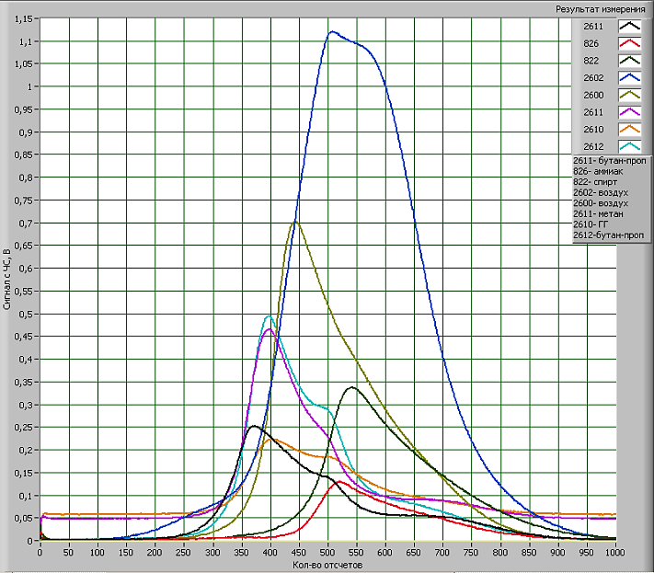

Figure 3. "Odor image" - acetone, concentration 49 ppm

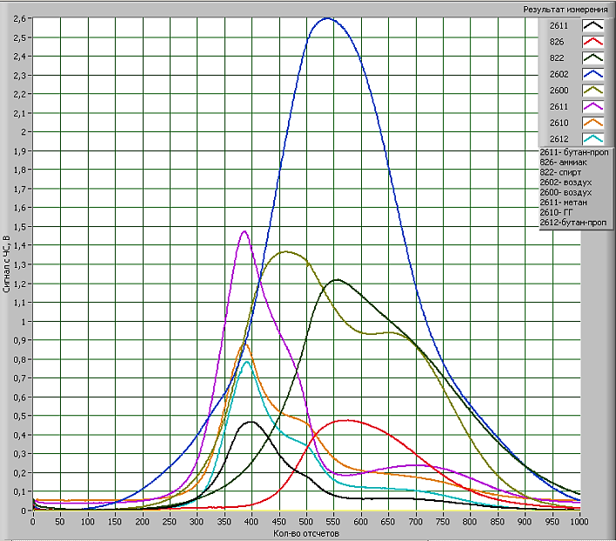

Figure 4. "Odor image" - acetone, concentration 926 ppm

The results of the experiments showed:
- the quality of the recognition of chemicals depends strongly on the volume of the educational base of images and the availability of examples of substances in different concentrations in the training base;
- with the increase of the training base, the quality of the classifier's work improves;
- when training a neural network, it is necessary to add samples with a low concentration of the substance classified;
- if, when learning a neural network on randomly chosen examples of each image or examples containing the maximum and minimum concentration of a substance, then testing the remaining examples will result in a 100% correct classification of the test cases;
- all the investigated gas mixtures are recognized, the error being not more than 5%;
- new smells, which the system did not learn, were classified as "NOT DETECTED" and were transferred to another category of smells while experimenting with the placement of images of gas mixtures in the library.
The resolving power of the matrix in the presence of background substances was determined by calculation in the results of tests in the form of probabilities of errors of the first kind and, depending on the target substance, was 45-67 ppm.

V CONCLUSION
Modern technologies of electronic instrumentation allow creating high-quality equipment for analytical instrument making. The use of a matrix of solid-state gas sensitive sensors, working in combination with modern digital processing of multiparameter signals, allows the creation of intelligent sensor systems (highly intelligent artificial nose) for the recognition of gas mixtures. Intelligence of the process of detection and recognition of odors is provided by the use of trained neural networks. The process of learning the neural network converter of odor into the code is provided by the learning algorithm in accordance with GOST R 52633.5.
Experimental studies using an experimental sample of a multisensory neural network "electronic nose" recognition system for gas mixtures (ethanol, isopropyl alcohol, acetone, methyl ethyl ketone, benzene, toluene, propane-butane) showed that the recognition error was not more than 5%..

ACKNOWLEDGMENTS
These studies are carried out with the financial support of the Russian Ministry of Education (unique identifier RFMEFI60815X0003).

REFERENCES
- Konduru T., Rains G.C., Li C. Customized Metal Oxide Semiconductor-Based Sensor Array for Onion Quality Evaluation: System Development and Characterization // Sensors. 2015. V.15. P.1252-1273.
- Giungato P., de Gennaro G., Barbieri P., Briguglio S., Amodio M., de Gennaro L., Lasigna F. Improving recognition of odors in a waste management plant by using electronic noses with different technologies, gas chromatography–mass spectrometry/olfactometry and dynamic olfactometry // Journal of Cleaner Production. 2016. 133, P. 1395-1402
- Possas-Abreu M., Ghassemi F., Rousseau L., Scorsone E., Descours E., Lissorgues G. Development of diamond and silicon MEMS sensor arrays with integrated readout for vapor detection // Sensors (Switzerland). 2017. 17(6), 1163
- Ahmadou D., Laref R., Losson E., Siadat M. Reduction of drift impact in gas sensor response to improve quantitative odor analysis // Proceedings of the IEEE International Conference on Industrial Technology. 2017.7915484, P. 928-933
- Suchorab Z., Sobczuk H., Guz Ł., Łagód, G. Gas sensors array as a device to classify mold threat of the buildings // Environmental Engineering V - Proceedings of the 5th National Congress of Environmental Engineering. 2017.P. 203-209
- Chen Z., Zheng Y., Chen K., Li H., Jian J. Concentration Estimator of Mixed VOC Gases Using Sensor Array with Neural Networks and Decision Tree Learning // IEEE Sensors Journal. 2017. 17(6), 7817845, P. 1884-1892
- Sharma S., Kumar R. Fuzzy relative entropy based classification scheme for discrimination of odors/gases using a poorly selective sensor array // 2016 IEEE International Conference on Fuzzy Systems, FUZZ-IEEE 2016 07737824, P. 1195-1200
- Alizadeh T., Hamedsoltani L. Managing of gas sensing characteristic of a reduced graphene oxide based gas sensor by the change in synthesis condition: A new approach for electronic nose design // Materials Chemistry and Physics. 2016. 183, P. 181-190
- Shakoorjavan S., Akbari S., Kish M.H., Akbari M. Correlation of sensory analysis with a virtual sensor array data for odour diagnosis of fragrant fabrics // Measurement: Journal of the International Measurement Confederation. 2016. 90, P. 396-403
- Sreelatha M., Nasira G.M., Thangamani P. Patten recognition for toxic gases based on electronic nose using artificial neural networks // Proceedings of the 10th INDIACom; 2016 3rd International Conference on Computing for Sustainable Global Development, INDIACom 2016 7724829, P. 3075-3079
- Kulagin V., Ivanov A.I., Kuznetsov Y.M., Chulkova G.M. Multidimensional mutual ordering of patterns using a set of pre-trained artificial neural networks // Journal of Physics: Conference Series. 2017. Vol. 803. No. 1
- Kulagin V., Kuznetsov Y.M., Chulkova G.M., Ivanov A., Ivannikov A.D. High Dimensional Neural Network Artificial Intelligence Capable of Quick Learning to Recognize a New Smell, and Gradually Expanding the Database, in: 2016 Third International Conference on Digital Information Processing, Data Mining, and Wireless Communications (DIPDMWC). M.: IEEE, 2016. P. 332-335
- Patent RU 171691U1 dated 06/09/2017. "The small-sized device" electronic nose "to detect odor-forming broad class of chemicals", 2017, Russia.
- GOST Р 52633.5-2011 Information protection. Information protection technology. The neural net biometry-code convertor automatic training.

